[Computer Graphics & multimedia lab]
[Indian institute of information technology ranchi]



Name: Anil Alok
Reg No: 2023UG1022
Section: A
Submitted To : Dr. Ankita Kumari

Setting up vs code

Step-1: Download following WinBGI files:
- graphics.h
- winbgim.h
- libbgi.h

Step-2: Copy following header files and place it in graphics.h and winbgim.h:
Code:- C:\Program Files (x86)\Dev-Cpp\MinGW64\include

Step-3: Copy library file and place it in libbgi.h:
Code:- C:\Program Files (x86)\Dev-Cpp\MinGW64\lib

Step-4: Configure linker in Dev-C++
- Open VS Code
- Go to Tools Compiler Options Linker
- Add this line under Linker options:
-lbgi -lgdi32 -lcomdlg32 -luuid -loleaut32 -lole32
Write a code to draw a line in C language.

#include <graphics.h>
#include <conio.h>

int main() {
int gd = DETECT, gm;
initgraph(&gd, &gm, "");
line(100, 100, 300, 300);
getch();
closegraph();
return 0;
}

OUTPUT:-


Write a code to draw the desired shape.

#include <graphics.h>
#include <conio.h>

void line(void) {
int i, gd = DETECT, gm;

initgraph(&gd, &gm, (char *)"");
setcolor(WHITE);
line(200, 300, 400, 300);
line(200, 400, 400, 400);
line(200, 300, 200, 400);
line(400, 300, 400, 400);

line(210, 310, 390, 310);
line(210, 390, 390, 390);
line(210, 310, 210, 390);
line(390, 310, 390, 390);

line(220, 320, 380, 320);
line(220, 380, 380, 380);
line(220, 320, 220, 380);
line(380, 320, 380, 380);

circle(300, 350, 22);
getch();
closegraph();
}

int main() {
line();
return 0;
}

OUTPUT:-

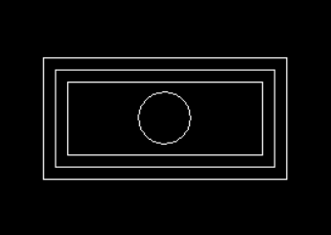
Write a code to draw any shape you want to create.

#include <graphics.h>
#include <conio.h>

void snowman(void) {
int i, gd = DETECT, gm;

initgraph(&gd, &gm, (char *)"");
setcolor(WHITE);
circle(300,150,50);
circle(300,300,100);
circle(280,130,7);
circle(320,130,7);
setfillstyle(SOLID_FILL, WHITE);
floodfill(300, 150, WHITE);
floodfill(300, 300, WHITE);
floodfill(300, 300, BLACK);
floodfill(300, 300, BLACK);

setcolor(RED);
line(300,150,300,165);
line(300,150,350,160);
line(300,165,350,160);

setcolor(BLUE);
circle(300,300,5);
setfillstyle(SOLID_FILL, BLUE);
floodfill(300, 300, BLUE);
circle(300,250,5);
setfillstyle(SOLID_FILL, BLUE);
floodfill(300, 250, BLUE);
circle(300,350,5);
setfillstyle(SOLID_FILL, BLUE);
floodfill(300, 350, BLUE);

setcolor(YELLOW);
line(250,100,350,100);
line(250,95,350,95);
line(250,100,250,95);
line(350,100,350,95);
line(270,80,330,80);
line(270,95,270,30);
line(330,95,330,30);
line(270,30,330,30);

setcolor(GREEN);
line(0,350,215,350);
line(385,350,5000,350);

setcolor(BROWN);
line(90,190,220,240);
line(500,190,380,240);

getch();
closegraph();
}

int main() {
snowman();
return 0;
}

OUTPUT:-

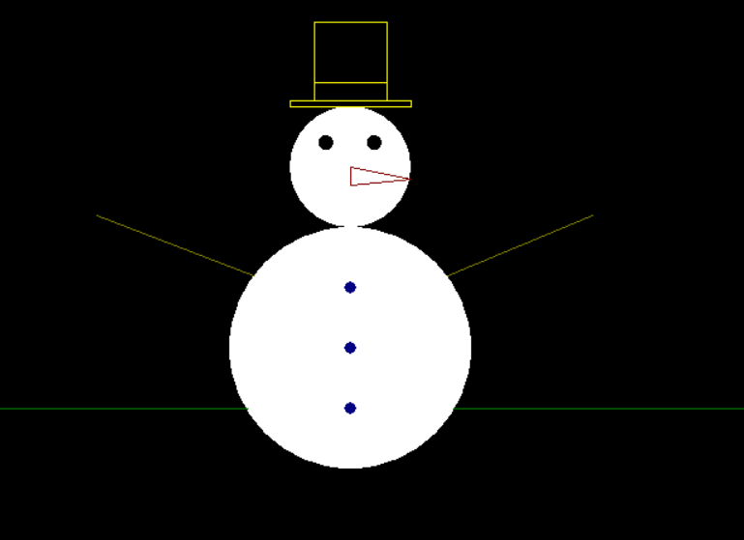

Write a code to draw a box and show pixels.

#include <graphics.h>
#include <conio.h>
#include <stdio.h>

void box(void) {
int i, gd = DETECT, gm;
initgraph(&gd, &gm, (char *)"");

setcolor(WHITE);
line(250,100,100,250);
line(250,100,400,250);
line(100,250,250,400);
line(400,250,250,400);

setfillstyle(SOLID_FILL, RED);
floodfill(100, 100, WHITE);

setfillstyle(SOLID_FILL, GREEN);
floodfill(250, 250, WHITE);

setcolor(WHITE);
circle(250,250,105);

setfillstyle(SOLID_FILL, BLUE);
floodfill(250, 250, WHITE);

char str[10];
for(int i=0;i<=700;i+=20){
for(int j=0;j<=700;j+=20){
sprintf(str,"%d",getpixel(0+i,0+j));
int x=0+i;
int y=0+j;
outtextxy(x,y,str);
}
}

getch();
closegraph();
}
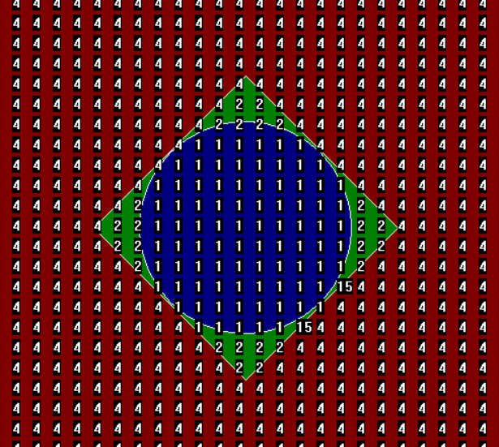
int main() {
box();
return 0;
}

Write a code to draw a concentric ellipse.

#include <graphics.h>
#include <conio.h>
#include <stdio.h>

void box(void) {
int i, gd = DETECT, gm;
initgraph(&gd, &gm, (char *)"");

setfillstyle(SOLID_FILL, RED);
fillellipse(300,210,80,180);
setfillstyle(SOLID_FILL, GREEN);
fillellipse(300,210,75,175);
setfillstyle(SOLID_FILL, BLUE);
fillellipse(300,210,70,170);
setfillstyle(SOLID_FILL, RED);
fillellipse(300,210,65,165);
setfillstyle(SOLID_FILL, GREEN);
fillellipse(300,210,60,160);
setfillstyle(SOLID_FILL, BLUE);
fillellipse(300,210,55,155);
setfillstyle(SOLID_FILL, RED);
fillellipse(300,210,50,150);
setfillstyle(SOLID_FILL, GREEN);
fillellipse(300,210,45,145);
setfillstyle(SOLID_FILL, BLUE);
fillellipse(300,210,40,140);
setfillstyle(SOLID_FILL, RED);
fillellipse(300,210,35,135);
setfillstyle(SOLID_FILL, GREEN);
fillellipse(300,210,30,130);
setfillstyle(SOLID_FILL, BLUE);
fillellipse(300,210,25,125);
setfillstyle(SOLID_FILL, RED);
fillellipse(300,210,20,120);
setfillstyle(SOLID_FILL, GREEN);
fillellipse(300,210,15,115);
setfillstyle(SOLID_FILL, BLUE);
fillellipse(300,210,10,110);
setfillstyle(SOLID_FILL, RED);
fillellipse(300,210,05,105);
setfillstyle(SOLID_FILL, GREEN);
fillellipse(300,210,00,100);

getch();
closegraph();
}

int main() {
box();
return 0;
}

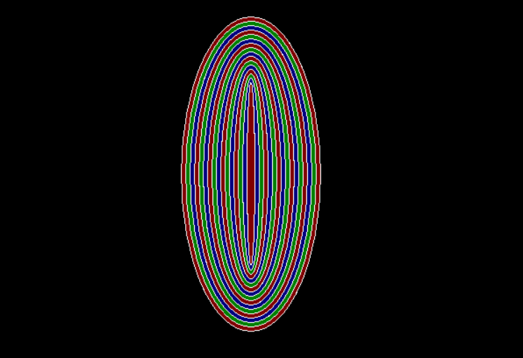

Write a code to make a resume using fonts.

#include <graphics.h>
#include <conio.h>

int main()
{
int height = 1000, width = 1200;
initwindow(width, height, "Anil Alok's Resume");
setbkcolor(WHITE);
cleardevice();

settextstyle(3, HORIZ_DIR, 6);
setcolor(BLACK);
outtextxy(450, 100, "RESUME");

settextstyle(4, HORIZ_DIR, 2);
setcolor(GREEN);
outtextxy(50, 175, "Name : Anil Alok ");

settextstyle(4, HORIZ_DIR, 2);
setcolor(RED);
outtextxy(50, 215, "Registration Number : 2023UG1022");

settextstyle(4, HORIZ_DIR, 2);
setcolor(BLUE);
outtextxy(50, 245, "Section : A");

//SUBJECTS
settextstyle(4, HORIZ_DIR, 2);
setcolor(GREEN);
outtextxy(50, 285, "Subject : Computer Graphics & Multimedia");

settextstyle(4, HORIZ_DIR, 2);
setcolor(BROWN);
outtextxy(50, 325, "Educational Qualification");
settextstyle(4, HORIZ_DIR, 1);
setcolor(BLACK);
outtextxy(50, 345, "1. High School: Secure 94.20 % in 10th from CBSE Board");
outtextxy(50, 365, "2. Intermediate: Secure 80 % in 12th from CBSE Board");
outtextxy(50, 385, "3. Currently Pursuing B.Tech from IIIT RANCHI with 8.42 CGPA");

settextstyle(4, HORIZ_DIR, 2);
setcolor(GREEN);
outtextxy(50, 425, "Eperience");
settextstyle(4, HORIZ_DIR, 1);
setcolor(BLACK);
outtextxy(50, 445, "1. Running a YouTube Channel 'Robosphere' related to IoT");
outtextxy(50, 465, "2. Iot engineer intern at 'Invent Lab Tech Pvt Ltd' for 6 months");
outtextxy(50, 485, "3. Selected for e-Toys Hackathon 2023 conducted by CDAC NOIDA");
settextstyle(4, HORIZ_DIR, 1);
setcolor(BLACK);
getch();
closegraph();
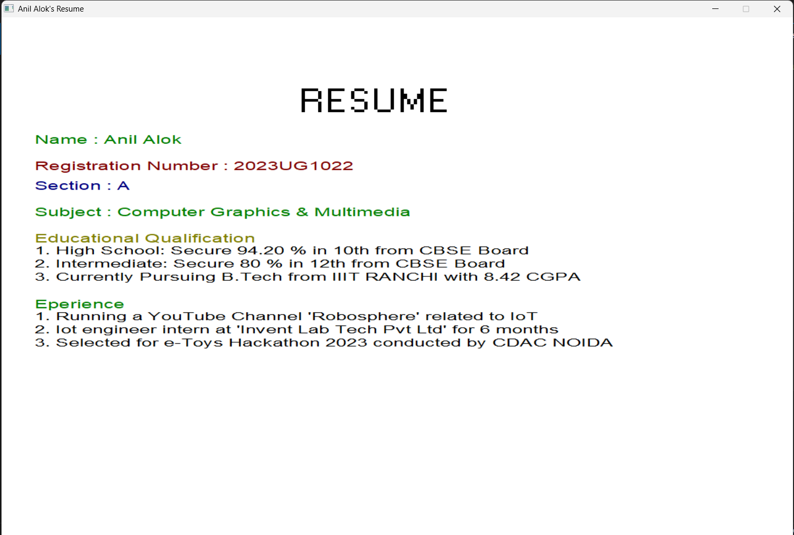
return 0; }
Write a code to make IIIT Ranchi logo.

#include <graphics.h>
#include <conio.h>

void logo(void) {
int i, gd = DETECT, gm;

initgraph(&gd, &gm, (char *)"");
setcolor(WHITE);
circle(300, 230, 150);
circle(300, 230, 110);
circle(300, 230, 10);
circle(300, 230, 50);
ellipse(300,230,50,50,25,70);
ellipse(300,230,50,50,70,25);
line(100, 400, 500, 400);
line(100, 400, 100, 450);
line(100, 450, 500, 450);
line(500, 400, 500, 450);
settextstyle(SMALL_FONT, HORIZ_DIR, 6);
setcolor(WHITE);
outtextxy(105, 420, " Indian Institute of Information Technology Ranchi");
settextstyle(DEFAULT_FONT, HORIZ_DIR, 2);
setcolor(WHITE);
outtextxy(230, 340, "Since 2016");

getch();
closegraph();
}

int main() {
logo();
return 0;
}



Write a program to draw a line using DDA algorithm.

#include <graphics.h>
#include <math.h>

void draw(int x1, int y1, int x2, int y2)
{
int dx = x2 - x1;
int dy = y2 - y1;

int steps = abs(dx) > abs(dy) ? abs(dx) : abs(dy);

float xInc = dx / (float)steps;
float yInc = dy / (float)steps;

float x = x1;
float y = y1;

for (int i = 0; i <= steps; i++)
{
putpixel(round(x), round(y), 15);
x += xInc;
y += yInc;
}
}

int main()
{
int gd = DETECT, gm, color;
initgraph(&gd, &gm, (char *)"");

draw(200, 300, 400, 300);

getch();
closegraph();
return 0;
}


Write a program to draw a line using Bresenham algorithm.

#include <graphics.h>
#include <iostream>
using namespace std;

void drawLineBresenham(int x1, int y1, int x2, int y2) {
int dx = x2 - x1;
int dy = y2 - y1;

int p = 2*dy - dx;
int x = x1, y = y1;

while (x <= x2) {
putpixel(x, y, WHITE);
x++;

if (p < 0) {
p += 2*dy;
} else {
y++;
p += 2*dy - 2*dx;
}
}
}

int main() {
int gd = DETECT, gm;
initgraph(&gd, &gm, "");

drawLineBresenham(200, 200, 400, 300);

getch();
closegraph();
return 0;
}



Write a program to perform all 2D transformations.

#include <graphics.h>
#include <conio.h>
#include <math.h>
#include <stdio.h>

void drawHouse(int x[], int y[]) {
for (int i = 0; i < 4; i++) {
line(x[i], y[i], x[(i + 1) % 4], y[(i + 1) % 4]);
}
line(x[0], y[0], x[4], y[4]);
line(x[1], y[1], x[4], y[4]);
}

int main() {
int gd = DETECT, gm;
initgraph(&gd, &gm, "");

int x[5] = {200, 300, 300, 200, 250}; // Last point for roof top
int y[5] = {300, 300, 400, 400, 250}; // Last point for roof top

int i, choice, opt;
float tx, ty, sx, sy, angle, shx, shy;

printf("\n2D Transformation on House\n");
printf("1. Translation\n2. Scaling\n3. Rotation\n4. Reflection\n5. Shearing\n");
printf("Enter your choice: ");
scanf("%d", &choice);

cleardevice();
setcolor(WHITE);
drawHouse(x, y);

setcolor(RED);

switch (choice) {
case 1:
printf("Enter translation factors tx and ty: ");
scanf("%f%f", &tx, &ty);
for (i = 0; i < 5; i++) {
x[i] += tx;
y[i] += ty;
}
break;

case 2:
printf("Enter scaling factors sx and sy: ");
scanf("%f%f", &sx, &sy);
for (i = 0; i < 5; i++) {
x[i] = 200 + (x[i] - 200) * sx;
y[i] = 300 + (y[i] - 300) * sy;
}
break;

case 3:
printf("Enter rotation angle in degrees: ");
scanf("%f", &angle);
angle = angle * 3.14159 / 180;
for (i = 0; i < 5; i++) {
int tempX = x[i];
x[i] = 250 + (tempX - 250) * cos(angle) - (y[i] - 300) * sin(angle);
y[i] = 300 + (tempX - 250) * sin(angle) + (y[i] - 300) * cos(angle);
}
break;

case 4:
printf("1. Reflect about X-axis\n2. Reflect about Y-axis\n");
scanf("%d", &opt);
if (opt == 1) {
for (i = 0; i < 5; i++)
y[i] = 480 - y[i];
} else {
for (i = 0; i < 5; i++)
x[i] = 640 - x[i];
}
break;

case 5:
printf("Enter shear factors shx and shy: ");
scanf("%f%f", &shx, &shy);
for (i = 0; i < 5; i++) {
int tempX = x[i];
x[i] = x[i] + shx * y[i];
y[i] = y[i] + shy * tempX;
}
break;

default:
printf("Invalid choice!");
}

drawHouse(x, y);
getch();
closegraph();
return 0;
}

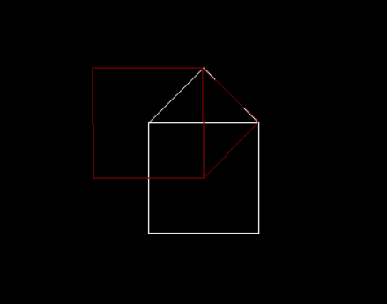
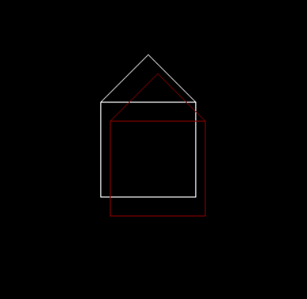

Translation Rotation
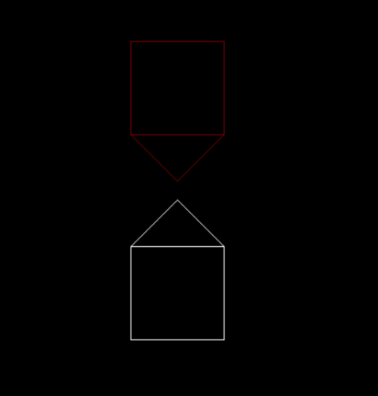
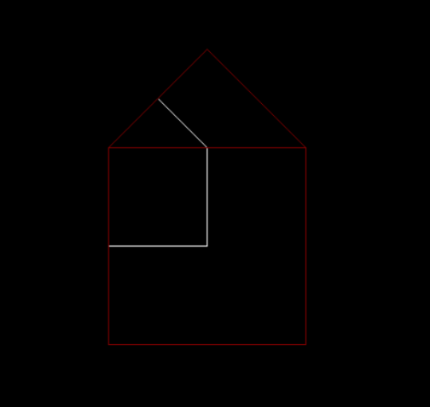
Scaling Reflection
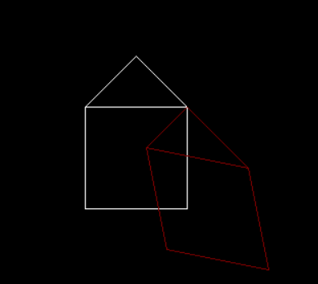

Shearing

Write a program to perform all 3D transformations.

#include <graphics.h>
#include <conio.h>
#include <math.h>
#include <stdio.h>

float x[8], y[8], z[8];

void projectPoint(float X, float Y, float Z, int *px, int *py) {
float angle = 45 * 3.14159 / 180;
float factor = 0.5;

*px = X + factor * Z * cos(angle);
*py = Y - factor * Z * sin(angle);
}

void drawCube() {
int px[8], py[8];

for (int i = 0; i < 8; i++)
projectPoint(x[i], y[i], z[i], &px[i], &py[i]);

line(px[0], py[0], px[1], py[1]);
line(px[1], py[1], px[2], py[2]);
line(px[2], py[2], px[3], py[3]);
line(px[3], py[3], px[0], py[0]);

line(px[4], py[4], px[5], py[5]);
line(px[5], py[5], px[6], py[6]);
line(px[6], py[6], px[7], py[7]);
line(px[7], py[7], px[4], py[4]);

line(px[0], py[0], px[4], py[4]);
line(px[1], py[1], px[5], py[5]);
line(px[2], py[2], px[6], py[6]);
line(px[3], py[3], px[7], py[7]);
}

int main() {
int gd = DETECT, gm;
initgraph(&gd, &gm, "");

x[0]=200; y[0]=200; z[0]=0;
x[1]=300; y[1]=200; z[1]=0;
x[2]=300; y[2]=300; z[2]=0;
x[3]=200; y[3]=300; z[3]=0;

x[4]=200; y[4]=200; z[4]=100;
x[5]=300; y[5]=200; z[5]=100;
x[6]=300; y[6]=300; z[6]=100;
x[7]=200; y[7]=300; z[7]=100;

int choice;
float tx, ty, tz, sx, sy, sz, shx, shy, shz, angle;

printf("\n3D Transformations on Cube\n");
printf("1. Translation\n2. Scaling\n3. Rotation (X-axis)\n4. Rotation (Y-axis)\n5. Rotation (Z-axis)\n6. Reflection\n7. Shearing\n");
printf("Enter your choice: ");
scanf("%d", &choice);

cleardevice();
setcolor(WHITE);
drawCube();

setcolor(RED);

switch (choice) {

case 1:
printf("Enter Tx, Ty, Tz: ");
scanf("%f %f %f", &tx, &ty, &tz);
for (int i = 0; i < 8; i++) {
x[i] += tx;
y[i] += ty;
z[i] += tz;
}
break;

case 2:
printf("Enter Sx, Sy, Sz: ");
scanf("%f %f %f", &sx, &sy, &sz);
for (int i = 0; i < 8; i++) {
x[i] = 250 + (x[i] - 250) * sx;
y[i] = 250 + (y[i] - 250) * sy;
z[i] = (z[i]) * sz;
}
break;

case 3:
printf("Enter angle: ");
scanf("%f", &angle);
angle = angle * 3.14159 / 180;
for (int i = 0; i < 8; i++) {
float ty = y[i], tz = z[i];
y[i] = ty * cos(angle) - tz * sin(angle);
z[i] = ty * sin(angle) + tz * cos(angle);
}
break;

case 4:
printf("Enter angle: ");
scanf("%f", &angle);
angle = angle * 3.14159 / 180;
for (int i = 0; i < 8; i++) {
float tx = x[i], tz = z[i];
x[i] = tx * cos(angle) + tz * sin(angle);
z[i] = -tx * sin(angle) + tz * cos(angle);
}
break;

case 5:
printf("Enter angle: ");
scanf("%f", &angle);
angle = angle * 3.14159 / 180;
for (int i = 0; i < 8; i++) {
float tx = x[i], ty = y[i];
x[i] = tx * cos(angle) - ty * sin(angle);
y[i] = tx * sin(angle) + ty * cos(angle);
}
break;

case 6:
printf("1. Reflect about XY-plane\n2. Reflect about YZ-plane\n3. Reflect about ZX-plane\n");
int opt;
scanf("%d", &opt);

for (int i = 0; i < 8; i++) {
if (opt == 1) z[i] = -z[i];
if (opt == 2) x[i] = -x[i];
if (opt == 3) y[i] = -y[i];
}
break;

case 7:
printf("Enter Shx, Shy, Shz: ");
scanf("%f %f %f", &shx, &shy, &shz);

for (int i = 0; i < 8; i++) {
float tx = x[i], ty = y[i], tz = z[i];
x[i] = tx + shx * tz;
y[i] = ty + shy * tz;
z[i] = tz + shz * tx;
}
break;

default:
printf("Invalid!");
}

drawCube();

getch();
closegraph();
return 0;
}
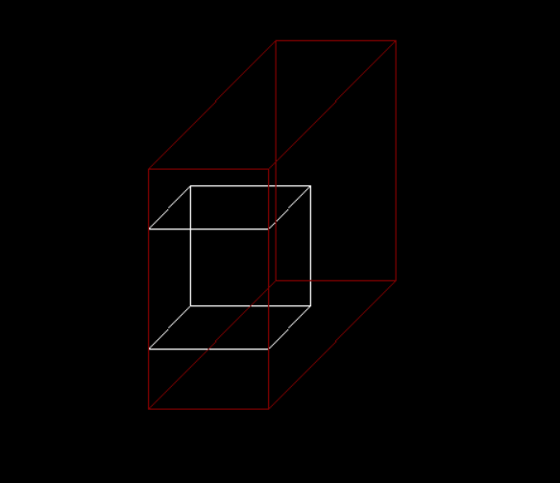
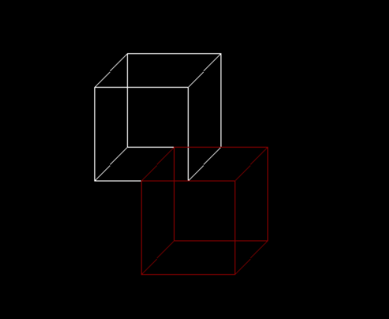

Translation Scaling
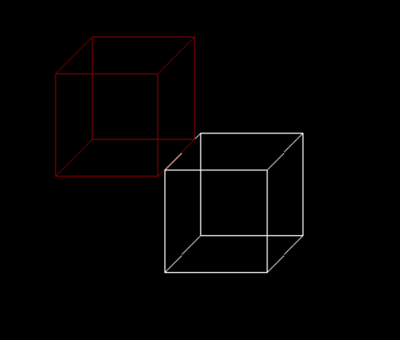

Reflection

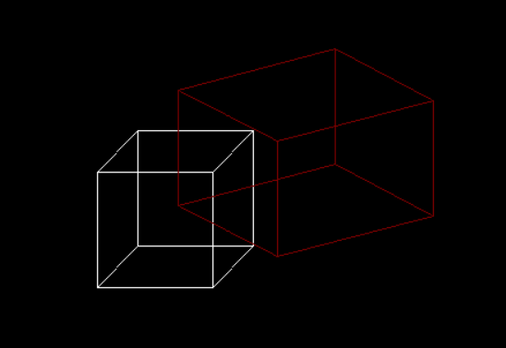

Shearing

